SCSR2043 OPERATING SYSTEMS

Name | : MOHAMMED MOHSEN MOHAMMED ALSAKKAF | Marks
Student ID | : A23CS4026
Section | : 01

This lab assessment is designed to test your understanding and skills on some basic concepts and tools related to operating system. Please follow the instructions carefully and submit your answers in this word document and rename the file as os-lab-assessment01-studentname-matricno.docx.

ACTIVITY 1 : | BASIC LINUX COMMANDS

In this activity, you will practice some basic Linux commands that are useful for operating system tasks. For each question, write down the command you used and the output you got in your answer file. If the command does not produce any output, write "No output" instead.

1. | Display your current working directory.
1. | Command | Output
1. | pwd | /home/kali
2. | List all the files and directories in your home directory, including hidden ones.
2. | Command | Output
2. | ls -a | 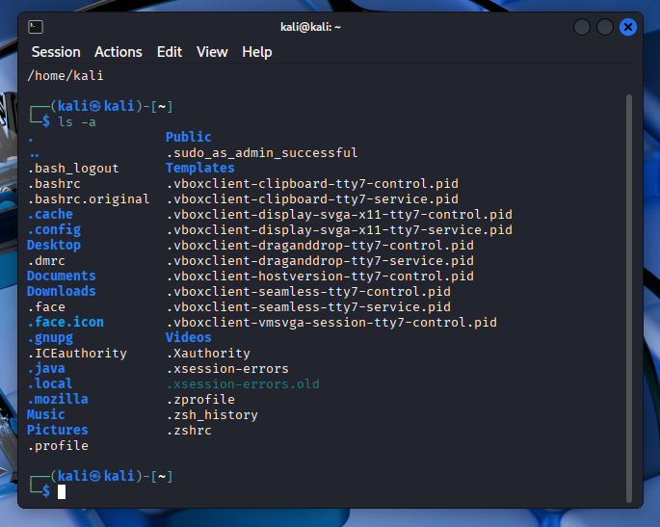
3. | Create a new directory named "os_lab" in your home directory. List all the files and directories before and after running this command to show the changes.
3. | Command | Output
3. | Ls  mkdir os_lab  Ls | 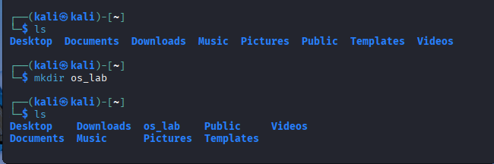
4. | Change your current working directory to "os_lab". Display your current location before and after running that command to show the changes.
4. | Command | Output
4. | pwd  cd os_lab  pwd | /home/kali  No Output  /home/kali/os_lab
5. | Create a new file named "hello.txt" in "os_lab" and write "Hello, world!" in it. List all the files and directories before and after running this command to show the changes.
5. | Command | Output
5. | ls  echo "Hello, World!" > hello.txt  ls | No Output  No Output  hello.txt

6. | Display the content of "hello.txt".
6. | Command | Output
6. | cat hello.txt | Hello, World!
7. | Copy "hello.txt" to another file named "hello_copy.txt" in the same directory. List all the files and directories before and after running this command to show the changes.
7. | Command | Output
7. | ls  cp hello.txt hello_copy.txt  ls | hello.txt  No Output  hello_copy.txt hello.txt
8. | Rename "hello_copy.txt" to "hello_bak.txt". List all the files and directories before and after running this command to show the changes.
8. | Command | Output
8. | ls  mv hello_copy.txt hello_bak.txt  ls | hello.txt hello_copy.txt  No output  hello.txt hello_bak.txt
9. | Delete "hello.txt". List all the files and directories before and after running this command to show the changes.
9. | Command | Output
9. | ls  rm hello.txt  ls | hello.txt hello_bak.txt  No output  hello_bak.txt
10. | Display your home directory with additional information, together with subdirectories contents.
10. | Command | Output
10. | ls -lR ~ | /home/kali:  total 36  drwxr-xr-x 2 kali kali 4096 Nov 4 13:00 Desktop  drwxr-xr-x 2 kali kali 4096 Nov 4 13:00 Documents drwxr-xr-x 2 kali kali 4096 Nov 4 13:00 Downloads drwxr-xr-x 2 kali kali 4096 Nov 4 13:00 Music drwxr-xr-x 2 kali kali 4096 Nov 4 13:05 os_lab  /home/kali/Desktop:  total 0  /home/kali/Documents:  total 0  /home/kali/Downloads:  total 0  /home/kali/Music:  total 0  /home/kali/os_lab:  total 4  -rw-r--r-- 1 kali kali 13 Nov 4 13:05 hello_bak.txt
 | Total Mark:

ACTIVITY 2 : | Text File Manipulation

In this activity, you will practice some commands to create and manipulate text files using echo, cat and touch.
For each question, write down the command and the output (if any) in the answer sheet.

1. | Create an empty file named "hello.txt" in the current working directory. List all the files and directories before and after running this command to show the changes.
1. | Command | Output
1. | ls  touch hello.txt  ls | 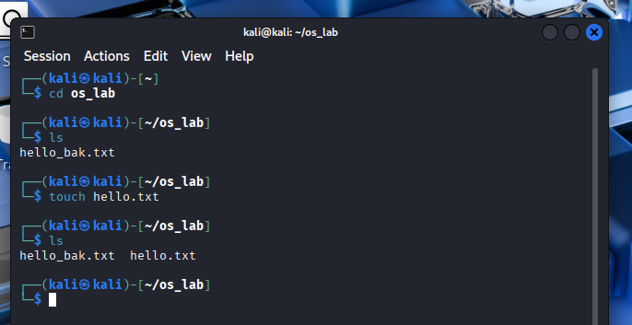
2. | Write the text "Hello World" to "hello.txt" using echo.
2. | Command | Output
2. | echo "Hello World" > hello.txt | No output
3. | Append the text "This is a test" to "hello.txt" using echo.
3. | Command | Output
3. | echo "This is a test" >> hello.txt | No output
4. | Display the contents of "hello.txt" using cat.
4. | Command | Output
4. | cat hello.txt | Hello World  This is a test
5. | Create another file named "bye.txt" with the text "Goodbye World" using echo.
5. | Command | Output
5. | echo "Goodbye World" > bye.txt | No output
6. | Concatenate the contents of "hello.txt" and "bye.txt" and display them using cat.
6. | Command | Output
6. | cat hello.txt bye.txt | Hello World  This is a test  Goodbye World
7. | Concatenate the contents of "hello.txt" and "bye.txt" and write them to a new file named "greeting.txt" using cat.
7. | Command | Output
7. | cat hello.txt bye.txt > greeting.txt | No output

8. | Display the contents of "greeting.txt" using cat.
8. | Command | Output
8. | cat greeting.txt | Hello World  This is a test  Goodbye World
9. | Edit the file "greeting.txt" using Nano and change the word "World" to your name in both lines.
9. | Command | Output
9. | nano greeting.txt | (Nano editor opens to edit the file)
10. | Display the modified contents of "greeting.txt" using cat.
10. | Command | Output
10. | cat greeting.txt | Hello Mohammed Alsakkaf  This is a test  Goodbye Mohammed Aslakkaf
 | Total Mark:

ACTIVITY 3 : | WRITE, COMPILE AND RUN C PROGRAM

In this activity, you will practice how to write, compile and run a simple C program using gcc. For each question, write down the command and the output (if any) in the answer sheet.

1. | Write a C program that prints "Hello World" to the standard output using Nano and save it as "hello.c".
1. | Command | Output
1. | nano hello.c | 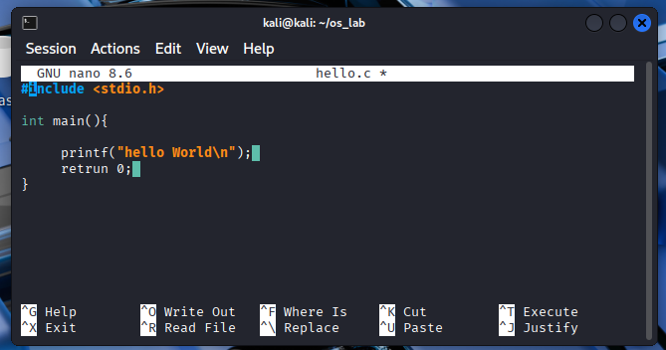
2. | Compile the program "hello.c" using gcc and generate an executable file named "hello". List all the files and directories before and after running this command to show the changes.
2. | Command | Output
2. | ls  gcc hello.c -o hello  ls | bye.txt greeting.txt hello.c hello.txt hello_bak.txt  No output  bye.txt greeting.txt hello hello.c hello.txt hello_bak.txt
3. | Run the executable file "hello" and display its output.
3. | Command | Output
3. | ./hello | Hello World
4. | Write a C program that takes two integers as command line arguments and prints their sum to the standard output using Nano and save it as "sum.c".
4. | Command | Output
4. | nano sum.c | 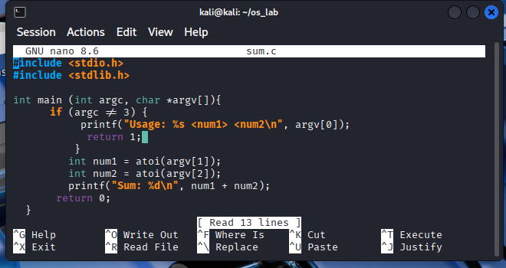
5. | Compile the program "sum.c" using gcc and generate an executable file named "sum". List all the files and directories before and after running this command to show the changes.
5. | Command | Output
5. | ls  gcc sum.c -o sum  ls | 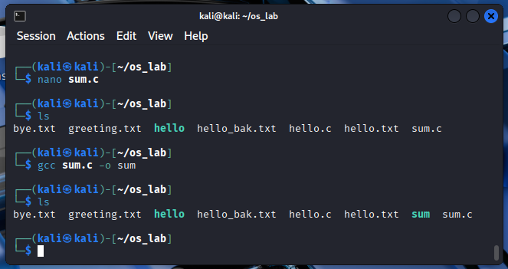
6. | Run the executable file "sum" with 10 and 20 as arguments and display its output.
6. | Command | Output
6. | ./sum 10 20 | Sum: 30
7. | Run the executable file "sum" with -5 and 15 as arguments and display its output.
7. | Command | Output
7. | ./sum -5 15 | Sum: 10

8. | Write a C program that reads a line of text from the standard input and prints it to the standard output using Nano and save it as "echo.c".
8. | Command | Output
8. | nano echo.c | 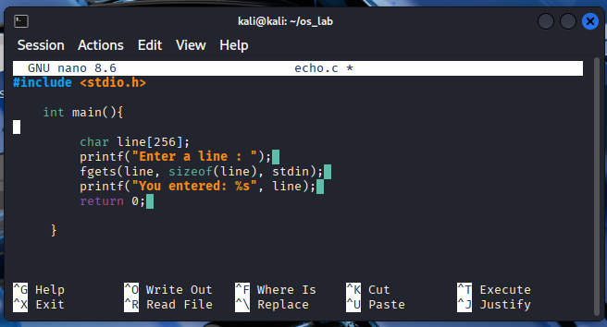
9. | Compile the program "echo.c" using gcc and generate an executable file named "echo". List all the files and directories before and after running this command to show the changes.
9. | Command | Output
9. | ls  gcc echo.c -o echo  ls | 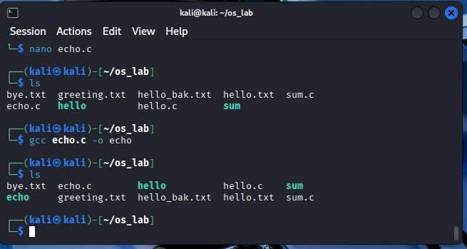
10. | Run the executable file "echo", type "Hello World" as input and display its output.
10. | Command | Output
10. | ./echo | 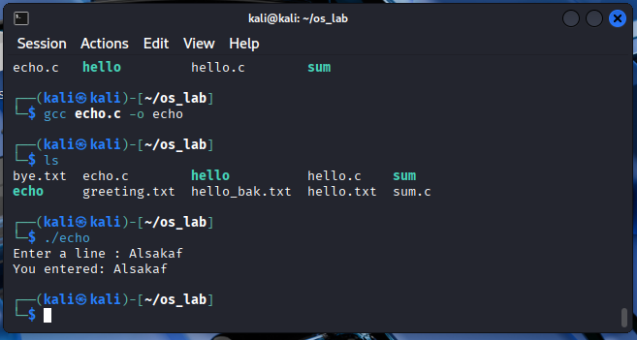
 | Total Mark:

